Table of Contents

1, Upload adv_zabbix_linux_agent.3.0.4.tar.gz to server 0

2, Confirm your directory and perform sudo su – become to root 0

3, Uncompress adv_zabbix_linux_agent.3.0.4.tar.gz and cd enter 0

4, Execute sh zabbix3.0.4_agent.sh to auto install zabbix agent 1

5, Confirm zabbix agent has already running and will auto start in server restart. 1

6, Add the host to zabbix monitoring 2

7, Check latest data 8

# 1, Upload adv_zabbix_linux_agent.3.0.4.tar.gz to server

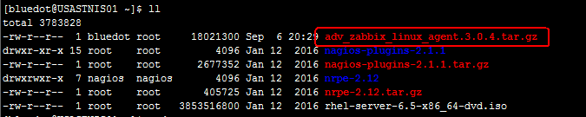

# 2, Confirm your directory and perform sudo su – become to root

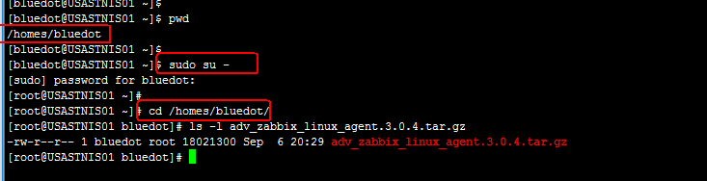

# 3, Uncompress adv_zabbix_linux_agent.3.0.4.tar.gz and cd enter



# 4, Execute sh zabbix3.0.4_agent.sh to auto install zabbix agent

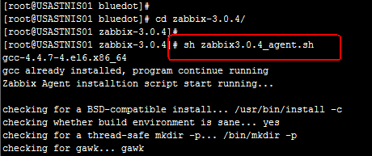

And now, zabbix agent has been installed, and started.

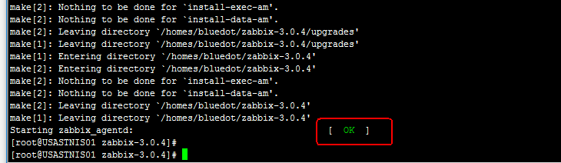

# 5, Confirm zabbix agent has already running and will auto start in server restart.

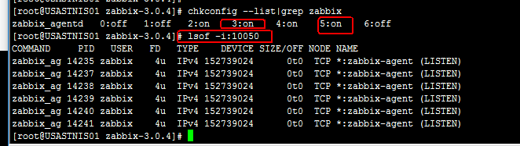

All installation has done.

# 6, Add the host to zabbix monitoring

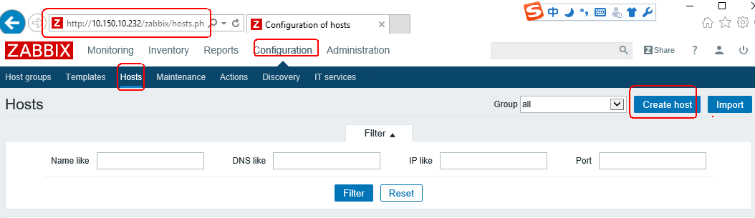

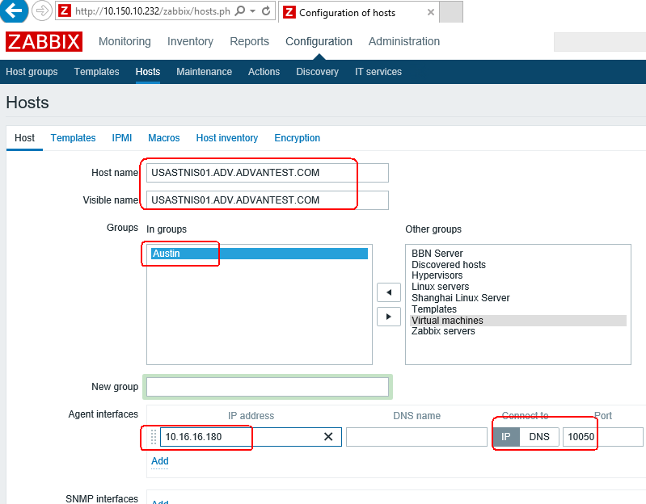

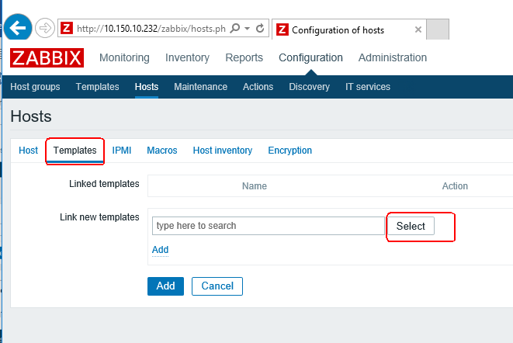

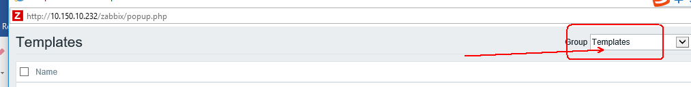

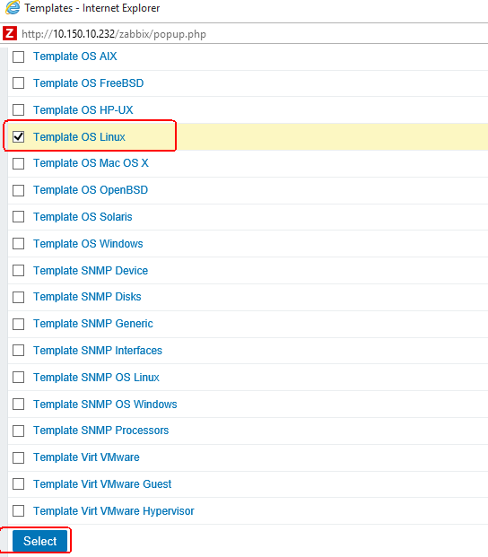

Then, Wait a few minutes. Less than 5 minute.

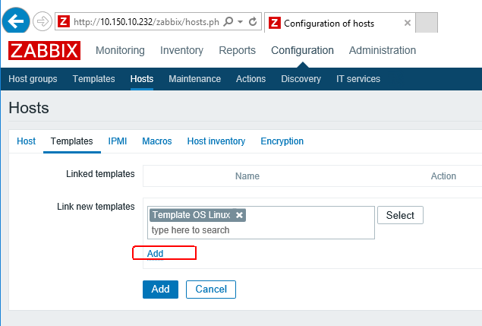

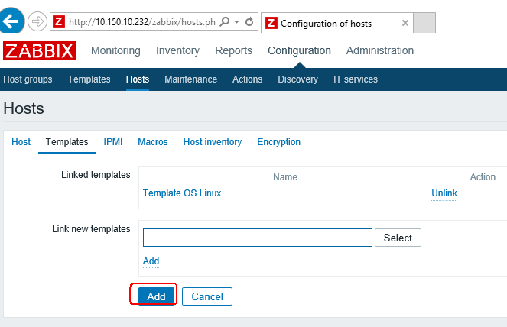

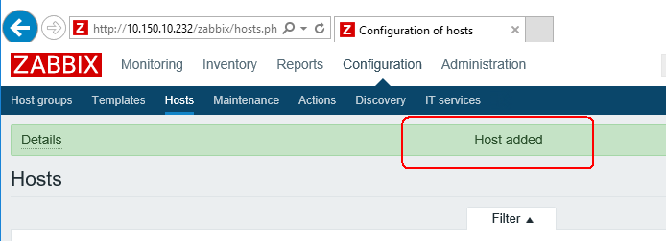

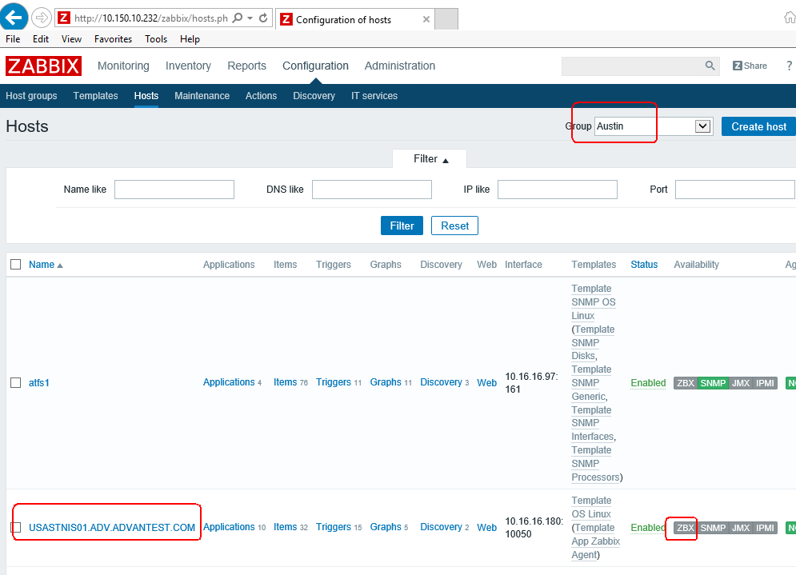

Now, ZABBIX has already monitoring this server with agent successfully.

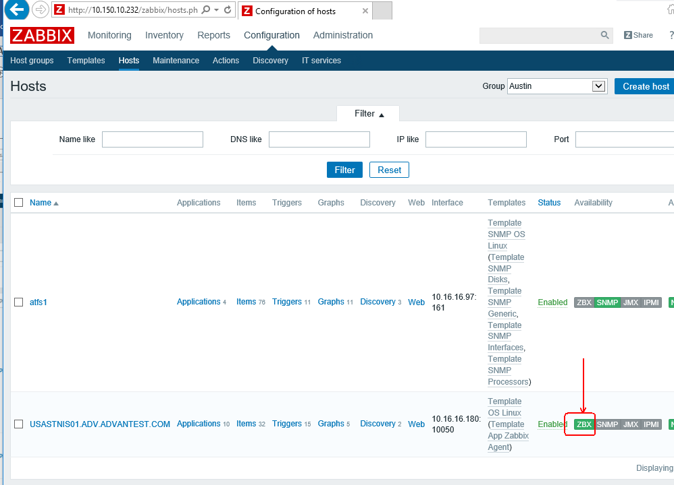

# 7, Check latest data

